Tracing the Growth of the Global Community: A Population Forecasting Analysis

INTRODUCTION

# Overview

Global Population Growth and Sustainable Development probes the linkages between global population growth and the social, economic and environmental dimensions of sustainable development. The report examines how the current rapid growth of the human population is a consequence of the demographic transition from high to low levels of mortality and fertility

# Purpose

# Population growth is essential as it**creates a larger workforce**, more people to contribute money for the country through taxes and provides better opportunities in entrepreneurship.

* The human population has experienced a period of unprecedented growth, more than tripling in size since 1950. It reached almost 7.8 billion in 2020 and is projected to grow to over 8.5 billion in 2030, the target date for achievement of the**Sustainable Development Goals** (SDGs).

The Purpose of the project is to analyze the population in UN states and find out the remedies to maintain the population growth

PROBLEM DEFINITION & DESIGN THINKING

# Empathy Map

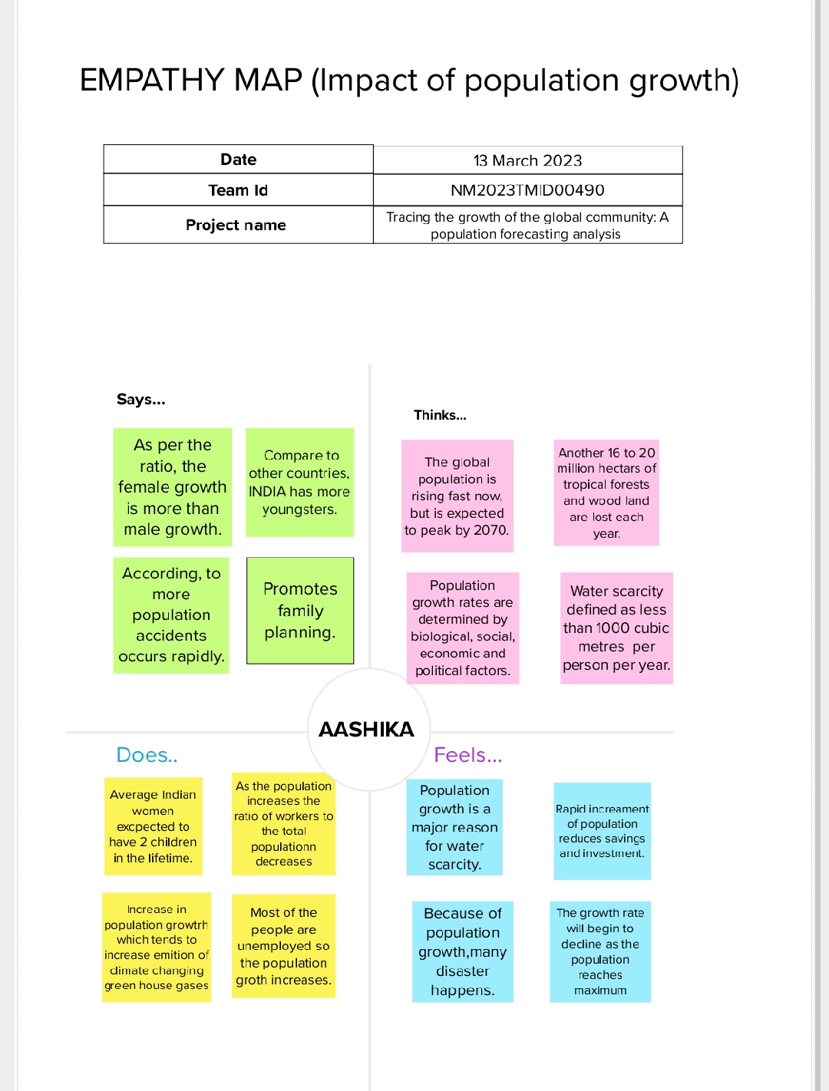

# Ideation & Brainstorming Map

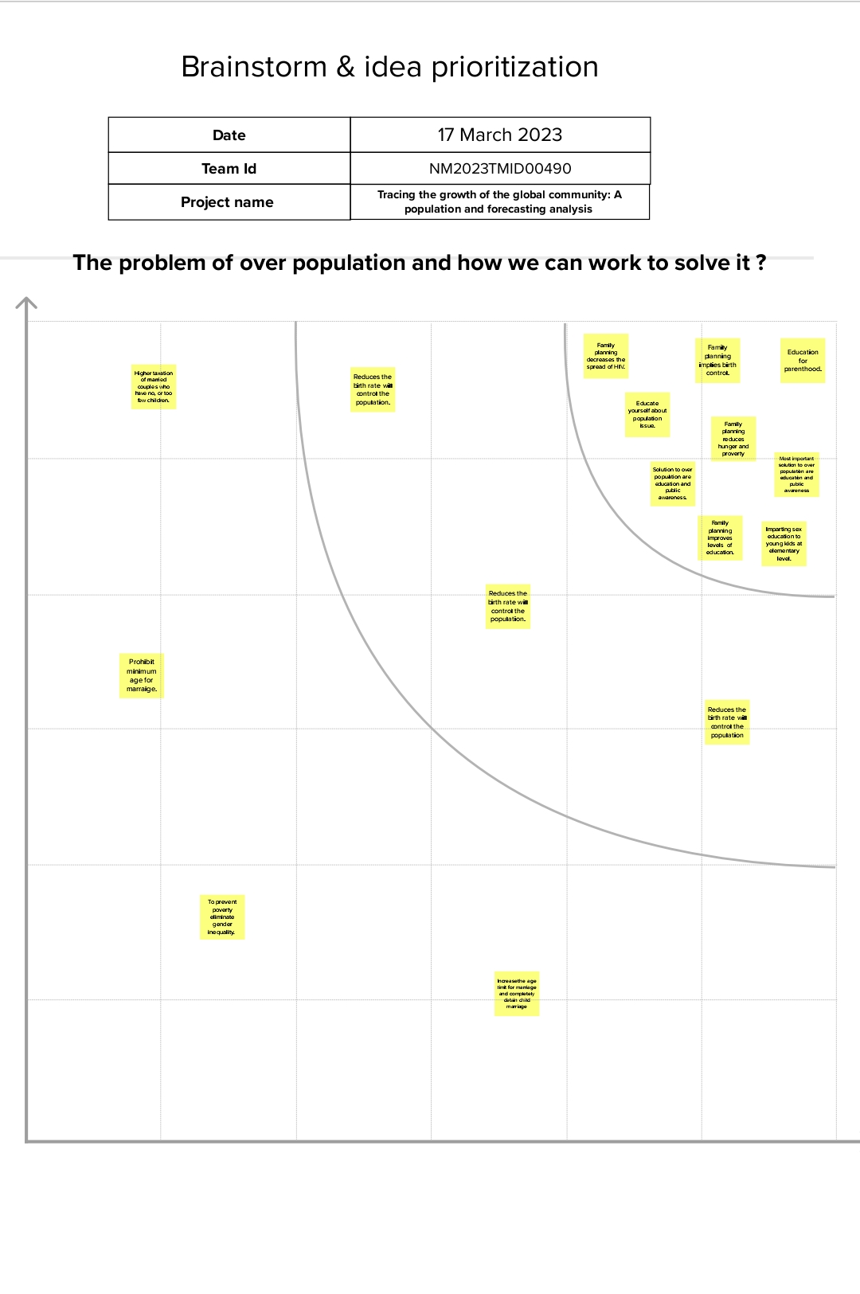

RESULT

# Dashboard 1

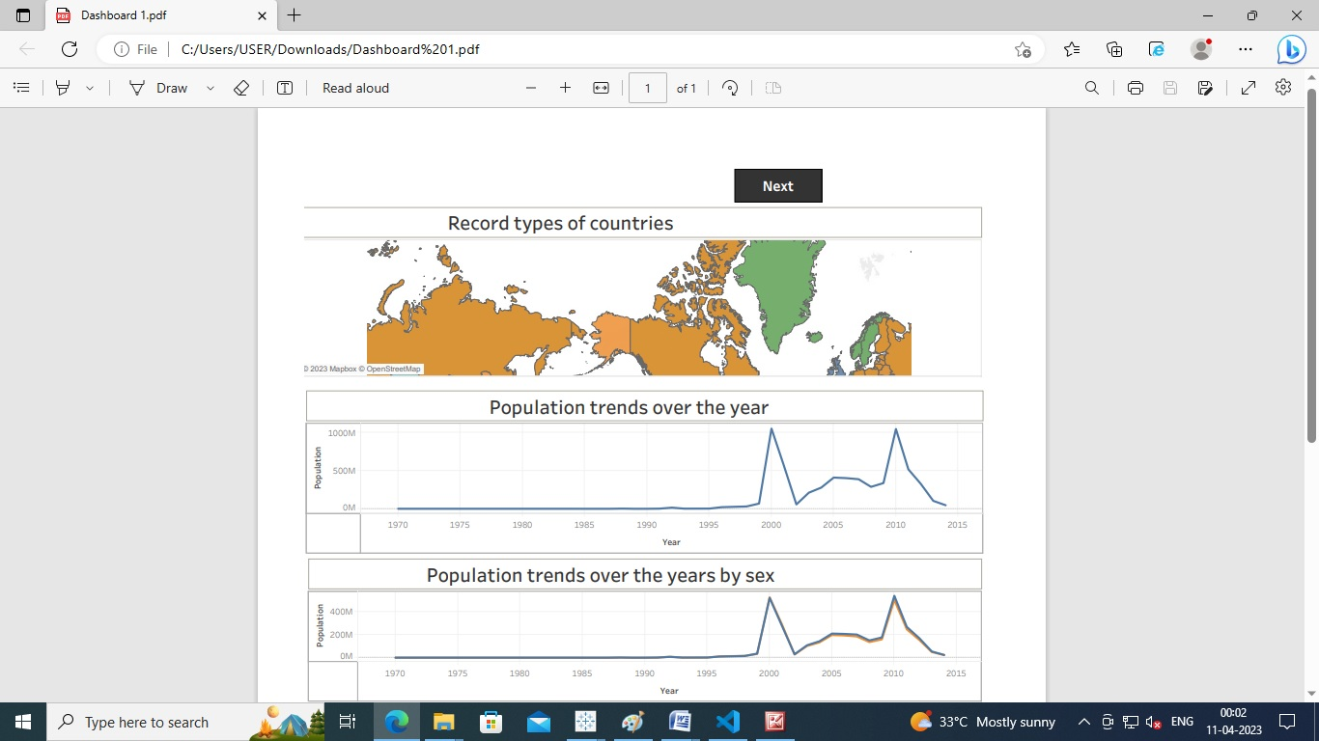

# Dashboard 2

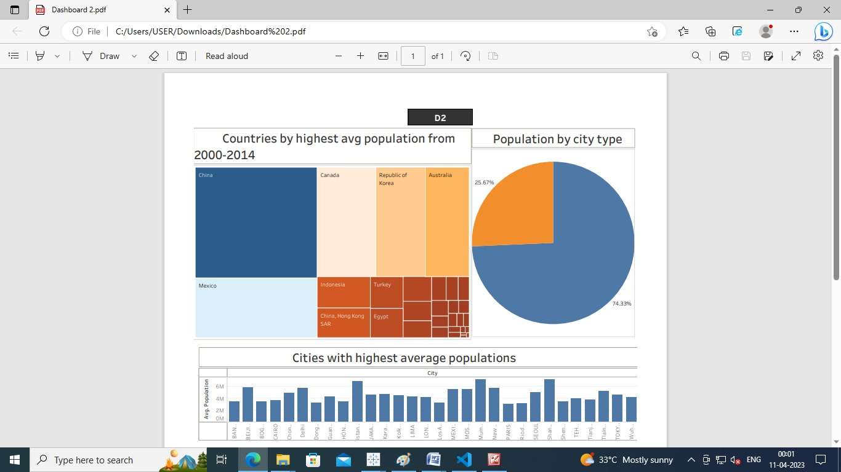

# Dashboard 3

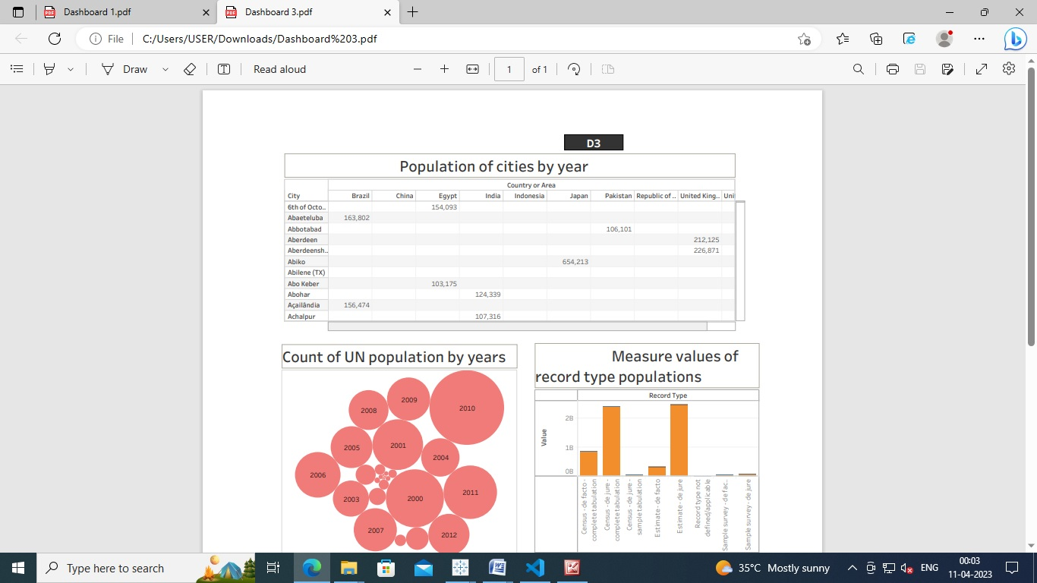

# Dashboard 4

# F:\screenshots\Dashboard4.jpg

ADVANTAGES & DISADVANTAGES

# Advantages:

1. **More people leads to greater human capital:**

The past 200 years have shown exponential growth in technical development and innovation. There are many factors behind this, but the world’s growing population means we have a bigger pool of human capital and the possibility of this cutting edge discover increase.

1. Higher economic growth:

Population growth will lead to economic growth with more people able to produce more goods. It will lead to higher tax revenues which can be spent on public goods, such as health care and environmental projects.

The obvious evaluation is to say, the crucial thing is not GDP, but [GDP per capita](https://www.economicshelp.org/blog/glossary/real-gdp-capita/). However, it is possible population growth can also improve per capita incomes. As the population increases, the economy can benefit from a bigger talent pool, economies of scale and greater specialization. All this can enable higher per capita income, which we have seen in major developed economies.

1. **Economies of scale:**

Farming and industry have been able to benefit from economies of scale, which means as the population grows, food output and manufacturing output have been able to grow even faster than population growth.

1. The efficiency of higher population density:

In terms of per capita carbon footprint, areas with a high population density are significantly more efficient than rural areas and places with a low population. In big cities, transport and the delivery of goods is much more efficient, whereas for low population densities, the average cost and environmental footprint are much higher.

In [Green Metropolis](https://books.google.co.uk/books?id=Wkeu5PHQ_ygC&printsec=frontcover&dq=Green+Metropolis&hl=en&ei=lfjETqiuFuLq0gHbuMCeDw&sa=X&oi=book_result&ct=result&redir_esc=y#v=onepage&q&f=fals), by David Owen he argues living in closer proximity in cities is a key aspect of sustainability

Urban areas account for only 3% of the world’s land surface. But, more than 50% of the population. By 2050, the [United Nations](https://web.archive.org/web/20220217170314/https:/www.un.org/development/desa/en/news/population/2018-revision-of-world-urbanization-prospects.html) predict this will rise to 70%. Therefore, population growth doesn’t have to lead to an equivalent fall in natural habitats.

1. **The improved demographic structure of society:**

Many western economies are now experiencing a falling population, with the result that their population demographic is being skewed to old, retired people. This is imposing costs on society as we struggle to pay for health care and pensions. Moderate population growth helps to rebalance the population with a higher share of young, working people.

1. **Critical mass**:

Higher populations can enable a critical mass of people to enable a wider, more vibrant society. With low populations, there is less scope for diversity. But, when the population grows, it can enable the support of a broader cultural range of activities.

# Disadvantages:

1. Cost to the environment:

 Population growth exacerbates many of the existing environmental problems

* Trying to reduce carbon and methane emissions to reduce global warming is relatively more difficult as the population.
* There will be greater threat on natural habitats as a greater population has greater demand for housing and farmland. This will increase pressure to cut down forests to make way for farming and housing.
* Higher population will lead to a greater consumption of non-renewable resources, leading to a faster depletion of natural resources.
* Higher population will lead to greater pollution levels in air, water and land. Higher pollution is associated with a range of health issues, such as cancer and asthma. The pollution also harms animals and plants.
* Soil degradation. To feed a growing planet, we have seen serious degrading of farmland (according to UN estimates) about 12 million hectares of farmland every year. This is due to factors, such as overgrazing, use of chemicals, climate change and use of chemicals.

2. Congestion:

Too many people in a small space will lead to various types of congestion. Road congestion is a major problem across the world. One study suggested [congestion](https://igees.gov.ie/wp-content/uploads/2018/07/Cost-of-Congestion-Appendix-A-International-Evidence.pdf) cost the EU €111bn (1% of GDP) in 2012. With population growth, the costs of congestion will only increase leading to time lost, more pollution and lost output.

3. Water shortages:

Already up to 40% of the world’s population phase water scarcity and the risk of drought. According to the [UN](https://www.unccd.int/actions/drought-initiative) water shortages could lead to 700 million people at the risk of displacement. A growing population will put pressure on scarce water supplies and this is a factor behind many minor and major conflicts with countries having to find ways around the shortage of water.

4. Generating unsustainable waste:

We are and other toxic problems .Currently generating non-biodegradable rubbish that we are struggling to process. It tends to end in landfill, causing methane emissions

APPLICATIONS

Population growth is the increase in the number of humans on Earth. For most of human history our population size was relatively stable. But with [**innovation**](https://ugc.berkeley.edu/background-content/innovation/) and industrialization, energy, [**food**](https://ugc.berkeley.edu/background-content/food-availability-and-nutrition/), [**water**](https://ugc.berkeley.edu/background-content/freshwater-quality-and-availability/), and [**medical care**](https://ugc.berkeley.edu/background-content/health-disease/) became more available and reliable. Consequently, global human population rapidly increased, and continues to do so, with dramatic impacts on global climate and ecosystems. We will need technological and social innovation to help us support the world’s population as we adapt to and mitigate climate and environmental changes.

* Increasing the [**extraction of resources**](https://ugc.berkeley.edu/background-content/resource-extraction/) from the environment. These resources include [**fossil fuels**](https://ugc.berkeley.edu/background-content/burning-of-fossil-fuels/) (oil, gas, and coal), minerals, [**trees**](https://ugc.berkeley.edu/background-content/deforestation-reforestation/), **water**, and [**wildlife**](https://ugc.berkeley.edu/background-content/fishing-hunting/), especially in the oceans. The process of removing resources, in turn, often releases [**pollutants and waste**](https://ugc.berkeley.edu/background-content/pollutants-and-waste/) that reduce [**air**](https://ugc.berkeley.edu/background-content/air-quality/) and **water quality**, and harm the **health**of humans and other species.
* Increasing the **burning of** **fossil fuels** for energy to generate electricity, and to power transportation (for example, cars and planes) and industrial processes.
* Increase in **freshwater use** for drinking, [**agriculture**](https://ugc.berkeley.edu/background-content/agricultural-activities/), recreation, and industrial processes. Freshwater is **extracted**from lakes, rivers, the ground, and man-made reservoirs.
* Increasing ecological impacts on environments. **Forests** and other [**habitats**](https://ugc.berkeley.edu/background-content/habitat-loss-restoration/) are disturbed or destroyed to construct [**urban areas**](https://ugc.berkeley.edu/background-content/urbanization/) including the construction of homes, businesses, and roads to accommodate growing populations. Additionally, as populations increase, more land is used for **agricultural activities** to grow crops and support livestock. This, in turn, can decrease [species populations](https://ugc.berkeley.edu/background-content/species-populations/)**,**geographic[ranges](https://ugc.berkeley.edu/background-content/species-ranges/)**,**[biodiversity](https://ugc.berkeley.edu/background-content/biodiversity/)**,** and alter [**interactions**](https://ugc.berkeley.edu/background-content/species-interactions/) among organisms.
* **Increasing fishing and hunting**, which reduces **species populations**of the exploited species. Fishing and hunting can also indirectly increase numbers of species that are not fished or hunted if more resources become available for the species that remain in the ecosystem.
* Increasing the transport of [**invasive species**](https://ugc.berkeley.edu/background-content/invasive-species/), either intentionally or by accident, as people travel and import and export supplies. Urbanization also creates disturbed environments where **invasive species**often thrive and out compute native species. For example, many invasive plant species thrive along strips of land next to roads and highways.
* The transmission of **diseases**. Humans living in densely populated areas can rapidly spread diseases within and among populations. Additionally, because transportation has become easier and more frequent, diseases can spread quickly to new regions.

CONCLUSION

To conclude I would say it is not only the responsibility of Government even NGO’s, society, and individuals should work creating awareness. Today almost everyone using social media, it can be used as tool to create awareness and control population explosion in India.

* Overpopulation may lead to many issues like depletion of natural resources, environmental pollution and degradation and loss of surroundings.  All countries must take immediate steps to control and manage human population growth.
* The Earth’s current population is almost 7.6 billion people and it is expanding. It is expected to surpass 8 billion people by 2025, 9 billion by 2040 and 11 billion by 2100.
* The current population of India is around 140crores.
* According to certain reports, in the next few years, there will be a solid growth of population in India, and globally too.

FUTURE SCOPE

## 1. Family Planning Measures

Family planning is an important device for controlling the population explosion. Family planning means **“Limiting the size of the family by conscious efforts”**. The motto of family planning is **“Child by choice, and not by chance”** family planning is an instrument of social transformation.

Family planning methods can be adopted in 2 ways. They are

* + 1. Birth Control
    2. Moral Control

2. Economic Measures

The economic measures help a common man in a lot of areas which indirectly helps to have smaller family that controls population explosion mentioned are as follows

**a) Rapid Industrial Development**

**b) Provision of Education**

**c) Agricultural Development**

**d) Development of Trade and Commerce**

**e) Incentives and Disincentives**

## 3. Social Measures

You may be thing how social measure can help in controlling population explosion, here are some of the measures that indirectly make people to have small family.

1. **Improving the status of women**
2. **Removal of Ignorance**
3. **Increasing the age of Marriage**

**Appendix**

Source Code

|  |  |
| --- | --- |
|  | Dashboard 1 |
|  | |  |  | | --- | --- | |  | <div class='tableauPlaceholder' id='viz1681377090844' style='position: relative'><noscript><a href='#'><img alt='Dashboard 1 ' src='https:&#47;&#47;public.tableau.com&#47;static&#47;images&#47;da&#47;dashboard1_16811066177570&#47;Dashboard1&#47;1_rss.png' style='border: none' /></a></noscript><object class='tableauViz' style='display:none;'><param name='host_url' value='https%3A%2F%2Fpublic.tableau.com%2F' /> <param name='embed_code_version' value='3' /> <param name='site_root' value='' /><param name='name' value='dashboard1_16811066177570&#47;Dashboard1' /><param name='tabs' value='no' /><param name='toolbar' value='yes' /><param name='static_image' value='https:&#47;&#47;public.tableau.com&#47;static&#47;images&#47;da&#47;dashboard1_16811066177570&#47;Dashboard1&#47;1.png' /> <param name='animate_transition' value='yes' /><param name='display_static_image' value='yes' /><param name='display_spinner' value='yes' /><param name='display_overlay' value='yes' /><param name='display_count' value='yes' /><param name='language' value='en-US' /></object></div> <script type='text/javascript'> var divElement = document.getElementById('viz1681377090844'); var vizElement = divElement.getElementsByTagName('object')[0]; if ( divElement.offsetWidth > 800 ) { vizElement.style.width='1000px';vizElement.style.height='827px';} else if ( divElement.offsetWidth > 500 ) { vizElement.style.width='1000px';vizElement.style.height='827px';} else { vizElement.style.width='100%';vizElement.style.height='777px';} var scriptElement = document.createElement('script'); scriptElement.src = 'https://public.tableau.com/javascripts/api/viz_v1.js'; vizElement.parentNode.insertBefore(scriptElement, vizElement); </script> | |  | <script> | |  | Dashboard 2 | |  | <div class='tableauPlaceholder' id='viz1681377932789' style='position: relative'><noscript><a href='#'><img alt='Dashboard 2 ' src='https:&#47;&#47;public.tableau.com&#47;static&#47;images&#47;da&#47;dashboard2_16811067449180&#47;Dashboard2&#47;1_rss.png' style='border: none' /></a></noscript><object class='tableauViz' style='display:none;'><param name='host_url' value='https%3A%2F%2Fpublic.tableau.com%2F' /> <param name='embed_code_version' value='3' /> <param name='site_root' value='' /><param name='name' value='dashboard2_16811067449180&#47;Dashboard2' /><param name='tabs' value='no' /><param name='toolbar' value='yes' /><param name='static_image' value='https:&#47;&#47;public.tableau.com&#47;static&#47;images&#47;da&#47;dashboard2_16811067449180&#47;Dashboard2&#47;1.png' /> <param name='animate_transition' value='yes' /><param name='display_static_image' value='yes' /><param name='display_spinner' value='yes' /><param name='display_overlay' value='yes' /><param name='display_count' value='yes' /><param name='language' value='en-US' /></object></div> <script type='text/javascript'> var divElement = document.getElementById('viz1681377932789'); var vizElement = divElement.getElementsByTagName('object')[0]; if ( divElement.offsetWidth > 800 ) { vizElement.style.width='1000px';vizElement.style.height='827px';} else if ( divElement.offsetWidth > 500 ) { vizElement.style.width='1000px';vizElement.style.height='827px';} else { vizElement.style.width='100%';vizElement.style.height='927px';} var scriptElement = document.createElement('script'); scriptElement.src = 'https://public.tableau.com/javascripts/api/viz_v1.js'; vizElement.parentNode.insertBefore(scriptElement, vizElement); </script> | |  | <script>  Dashboard 3   |  | | --- | | <div id="dashboard"> | |  | <h1>Population Forecasting Analysis</h1> | |  | <!-- Add your population forecasting analysis dashboard components here --> | |  | <div id="chart-container"></div> | |  | <div id="controls-container"></div> | |  | <div id="results-container"></div> | |  |  | |  | <div class='tableauPlaceholder' id='viz1681378138502' style='position: relative'><noscript><a href='#'><img alt='Dashboard 3 ' src='https:&#47;&#47;public.tableau.com&#47;static&#47;images&#47;Da&#47;Dashboard3_16811069665810&#47;Dashboard3&#47;1_rss.png' style='border: none' /></a></noscript><object class='tableauViz' style='display:none;'><param name='host_url' value='https%3A%2F%2Fpublic.tableau.com%2F' /> <param name='embed_code_version' value='3' /> <param name='site_root' value='' /><param name='name' value='Dashboard3_16811069665810&#47;Dashboard3' /><param name='tabs' value='no' /><param name='toolbar' value='yes' /><param name='static_image' value='https:&#47;&#47;public.tableau.com&#47;static&#47;images&#47;Da&#47;Dashboard3_16811069665810&#47;Dashboard3&#47;1.png' /> <param name='animate_transition' value='yes' /><param name='display_static_image' value='yes' /><param name='display_spinner' value='yes' /><param name='display_overlay' value='yes' /><param name='display_count' value='yes' /><param name='language' value='en-US' /></object></div> <script type='text/javascript'> var divElement = document.getElementById('viz1681378138502'); var vizElement = divElement.getElementsByTagName('object')[0]; if ( divElement.offsetWidth > 800 ) { vizElement.style.width='1000px';vizElement.style.height='827px';} else if ( divElement.offsetWidth > 500 ) { vizElement.style.width='1000px';vizElement.style.height='827px';} else { vizElement.style.width='100%';vizElement.style.height='977px';} var scriptElement = document.createElement('script'); scriptElement.src = 'https://public.tableau.com/javascripts/api/viz_v1.js'; vizElement.parentNode.insertBefore(scriptElement, vizElement); </script> | |  | <script> | |  | // Your embedded code for population forecasting analysis | |  | </script> | |  | </div> |   Dashboard 4   |  | | --- | | <div id="dashboard"> | |  | <h1>Population Forecasting Analysis</h1> | |  | <!-- Add your population forecasting analysis dashboard components here --> | |  | <div id="chart-container"></div> | |  | <div id="controls-container"></div> | |  | <div id="results-container"></div> | |  |  | |  | <div class='tableauPlaceholder' id='viz1681378255099' style='position: relative'><noscript><a href='#'><img alt='Dashboard 4 ' src='https:&#47;&#47;public.tableau.com&#47;static&#47;images&#47;Da&#47;Dashboard4_16811070004100&#47;Dashboard4&#47;1_rss.png' style='border: none' /></a></noscript><object class='tableauViz' style='display:none;'><param name='host_url' value='https%3A%2F%2Fpublic.tableau.com%2F' /> <param name='embed_code_version' value='3' /> <param name='site_root' value='' /><param name='name' value='Dashboard4_16811070004100&#47;Dashboard4' /><param name='tabs' value='no' /><param name='toolbar' value='yes' /><param name='static_image' value='https:&#47;&#47;public.tableau.com&#47;static&#47;images&#47;Da&#47;Dashboard4_16811070004100&#47;Dashboard4&#47;1.png' /> <param name='animate_transition' value='yes' /><param name='display_static_image' value='yes' /><param name='display_spinner' value='yes' /><param name='display_overlay' value='yes' /><param name='display_count' value='yes' /><param name='language' value='en-US' /></object></div> <script type='text/javascript'> var divElement = document.getElementById('viz1681378255099'); var vizElement = divElement.getElementsByTagName('object')[0]; if ( divElement.offsetWidth > 800 ) { vizElement.style.width='1000px';vizElement.style.height='827px';} else if ( divElement.offsetWidth > 500 ) { vizElement.style.width='1000px';vizElement.style.height='827px';} else { vizElement.style.width='100%';vizElement.style.height='727px';} var scriptElement = document.createElement('script'); scriptElement.src = 'https://public.tableau.com/javascripts/api/viz_v1.js'; vizElement.parentNode.insertBefore(scriptElement, vizElement); </script> | |  | <script> | |  | // Your embedded code for population forecasting analysis | |  | </script> | |  | </div> |   Story   |  | | --- | | <div> | |  | <p>From <span id="start-year-display"></span> to <span id="end-year-display"></span>, with an initial population of <span id="initial-population-display"></span>, a birth rate of <span id="birth-rate-display"></span>, and a death rate of <span id="death-rate-display"></span>, the forecasted population is <span id="forecasted-population-display"></span>.</p> | |  | </div> | |  |  | | |  |  | |  |  | |  |  | |  |  | |  |  | |  |  | |  |  | |  |  | |  |  | |  |  | |  |  | |  |  | |  |  | |  |  | |  |  | |  |  | |  |  | |  |  | |  |  | |  |  | |  |  | |  |  | |  |  | |  |  | |  |  | |  |  | |  |  | |  |  | |  |  | |  |  | |  |  | |  |  | |  |  | |  |  | |  |  | |  |  | |  |  | |  |  | |  |  | |
|  |  |
|  |  |
|  |  |
|  |  |
|  |  |
|  |  |
|  |  |
|  |  |
|  |  |
|  |  |
|  |  |
|  |  |
|  |  |
|  |  |